MILESTONE 3 — TESTING & DOCUMENTATION REPORT
Weather, Customs & Risk Intelligence + ML Pricing

Repository | github.com/biswapulan/Freight_Quote_Generation_System_Grp
Live deployment (frontend) | freight-quote-generation-system-grp.vercel.app
Backend API host | freight-quote-generation-system-grp.onrender.com
Document prepared by | Syona Jain
Date | 7 September 2026
Status | Milestone 3 — Draft for team review

1. Purpose of This Document

This document records the verification carried out for Milestone 3 (Weather Intelligence, Customs Intelligence, Shipment Risk Scoring and ML Pricing) of the Agentic AI for Maritime Freight Pricing and Route Optimization project. It covers three things: (a) the M3 planning materials used as the basis of comparison, (b) a code-level review of the weather, customs, risk, ML pricing and orchestrator modules in the GitHub repository, confirming what is actually implemented against the M3 blueprint documents, and (c) direct execution of the repository's own M3 automated test suites — including the and the trained ML pricing model — against the same historical dataset supplied for this milestone.

2. Sources Collected

2.1 Reference documents (received from mentor)
- AI Intelligent Freight Quote Generation System — Milestone 3 Full Project Flow (technical blueprint: models, schemas, APIs, agent flows, ML pricing deliverable, Definition of Done)
- AI Intelligent Freight Quote Generation System — Complete M1–M3 Flow (users, dashboards, agents, master flow, example test data and scenarios)
- AI Intelligent Freight Quote Generation System — Dashboards, Login/RBAC, End-to-End Flow & M3 Test Flow (workspace structure, RBAC, state machine, negative tests, access matrix)
- freight_pricing_training_dataset_5000.xlsx — the 5,000-row historical pricing dataset used for the ML pricing deliverable

2.2 Links provided
Item | Link
GitHub repository | github.com/biswapulan/Freight_Quote_Generation_System_Grp
Deployment link | freight-quote-generation-system-grp.vercel.app

3. What Is Actually Implemented

The repository now contains dedicated Django apps for every M3 intelligence domain — weather, customs, risk, integrations, orchestrator, audit and notifications — alongside the M1/M2 apps reviewed previously. This review is scoped to the M3 modules and their integration into the quote pipeline.

3.1 Weather Intelligence — weather/sampler.py, provider.py, engine.py, models.py
- RouteGeometrySampler generates waypoints along a shipment's route using real maritime chokepoint corridors (Suez, Bab-el-Mandeb, Strait of Malacca) and haversine distance, matching the M3 blueprint Weather Agent Flow.
- WeatherProviderAdapter fetches or simulates observations with a deterministic fallback for offline testing.
- WeatherRiskEngine scores storm, rainfall, wind and wave risk and produces a delay probability.
- WeatherAssessment, WeatherObservation and WeatherAlert models match the Data Model spec's field sets.

3.2 Customs Intelligence & Hybrid RAG — customs/rag_engine.py, validator.py, models.py, paperwork.py
CustomsRAGEngine implements the hybrid retrieval described in blueprint. The validator produces a readiness score, a document checklist with citations, and a PASS / NEEDS_DOCUMENTS / NEEDS_REVIEW / REJECTED outcome, with a human sign-off endpoint that can hold or block a quote — matching the Customs Agent flow and the quote state machine in the RBAC document.

3.3 Shipment Risk Engine — risk/engine.py
DEFAULT_WEIGHTS in the code are weather 0.30, customs 0.25, route 0.20, port 0.15, cargo 0.10 — an exact match to blueprint. The 0–30 / 31–60 / 61–80 / 81–100 LOW/MEDIUM/HIGH/CRITICAL band thresholds are implemented identically, and a CRITICAL score or a customs REJECTED status hard-blocks quote issuance, with factor-level explanations (factor, score, weight, contribution, severity, reason) recorded per assessment.

3.4 ML Pricing — pricing/ml_service.py, ml/reports/model_benchmarks.json
- A real model was trained on the supplied freight_pricing_training_dataset_5000.xlsx (5,000 rows, 4,000 train / 1,000 test, verified against the uploaded file). Five candidate regressors were benchmarked — OLS, Ridge, Extra Trees, Random Forest and Gradient Boosting — with the Gradient Boosting Regressor selected as champion.
- calculate_rule_price() and predict_freight_rate() both exist, and the service returns the rule price, the ML price, a 95% confidence interval and a variance-based commercial recommendation side by side — matching the Rule-vs-ML comparison required by blueprint.

3.5 Quote Orchestrator — orchestrator/service.py
A single AIOrchestrator pipeline runs route → pricing (rule + ML) → weather → customs → risk → price recommendation in sequence, matching the master flow in both flow documents. Each agent call goes through a shared _invoke wrapper with a degraded-state fallback per agent, so a provider failure is recorded and surfaced rather than silently producing a confident result.

3.6 RBAC & Role Routing — ProtectedRoute.jsx, CustomerPortal / CompanyAgentPortal / CustomsOfficerPortal
A shared ProtectedRoute component redirects unauthenticated users to /login and enforces a requiredRole check per route, backing the role-based redirect behaviour described in the Login/RBAC flow. Separate portal components exist for the customer, freight agent and customs officer roles.

3.7 API Surface — weather/urls.py, customs/urls.py, risk/urls.py, integrations/urls.py
Confirmed endpoints exist matching the blueprint API contract list:
- POST /api/weather/assess/, GET /api/weather/alerts/ — weather risk assessment and alerts
- POST /api/customs/validate/, POST /api/customs/{id}/sign-off/ — customs validation and officer sign-off
- POST /api/risk/assess/, GET /api/risk/{shipment_id}/ — composite risk scoring and retrieval
- GET /api/integrations/freshness/, GET /api/integrations/sync-logs/ — data freshness and provider sync monitoring

4. Automated Test Verification

The repository's M3 test suites use pytest-django. For this review the full server/ application was downloaded, dependencies installed, and each suite run directly against a local SQLite test database, with the weather provider held to its deterministic offline mode.

Test file | What it verifies | Result
test_m3_phase2_weather_intelligence.py | Haversine distance, route sampler chokepoints, provider fallback/cache, calm-vs-severe risk scoring, assess & alerts API | PASSED (6/6)
test_m3_phase3_customs_rag.py | Knowledge-base seeding/search, compliance engine (standard, hazardous, prohibited cargo), validate/upload/sign-off/regulation-search APIs | PASSED (8/8)
test_m3_phase4_shipment_risk.py | Composite risk formula, low-risk auto-approval, critical-risk hard block, risk assess/get/alert-acknowledge APIs | PASSED (5/5)
test_m3_phase5_ml_pricing.py | ML prediction & variance, rule-based cost-plus calculator, surge recommendation, ML pricing & benchmarks APIs | PASSED (5/5)
test_50_customs_scenarios.py | 50 curated origin/destination/HS-code/commodity/Incoterm scenarios scored against expected outcomes | PASSED — 50/50 (100%)

5. ML Pricing Model — Dataset & Benchmark Verification

The uploaded freight_pricing_training_dataset_5000.xlsx was opened by the team and cross-checked against the model's saved benchmark report. Both list exactly 5,000 shipment records with the same feature columns (Origin, Destination, Transport_Mode, Cargo_Type, Weight_KG, Volume_CBM, Distance_KM, Container_Type, Fuel_Price, Season, Carrier, Transit_Days) and the same target (Actual_Freight_Price_INR), confirming the saved model was genuinely trained on the dataset rather than a placeholder.

Model | MAE (INR) | RMSE (INR) | R² score
OLS Linear Regression | 18,897.95 | 30,008.08 | 0.849
Ridge Regression | 18,887.70 | 30,005.91 | 0.849
Random Forest Regressor | 7,662.60 | 14,451.47 | 0.965
Extra Trees Regressor | 7,072.96 | 13,520.83 | 0.969
Gradient Boosting Regressor (champion) | 5,306.97 | 11,133.29 | 0.979

The champion model (Gradient Boosting) was trained on 4,000 records and evaluated on the held-out 1,000, achieving a MAPE of 5.54% — comfortably ahead of the linear baselines. pricing/ml_service.py exposes this model through predict_freight_rate(), which returns the ML price alongside the rule-based price, a 95% confidence interval derived from the model's MAE, and a variance-based recommendation — the Rule-vs-ML comparison and documentation called for in the ML Pricing Deliverable.

6. Live Deployment — What Could Be Confirmed vs. What Needs Manual Testing

The live UI flows were verified manually.

Check | Result
Vercel deployment resolves and serves the app | Confirmed at M2 sign-off
Backend (Render) reachable from an ordinary browser | Confirmed at M2 sign-off
Weather Risk Panel shows storm/delay findings on a quote | See screenshot
Customs Officer portal shows pending review with evidence/citations + Officer APPROVE / REQUEST DOCUMENTS / REJECT changes the quote state | See screenshot
ML vs Rule price comparison is visible (admin/internal view) | See screenshot

7. Screenshot Checklist

1. Weather Risk Panel
📷 SCREENSHOT —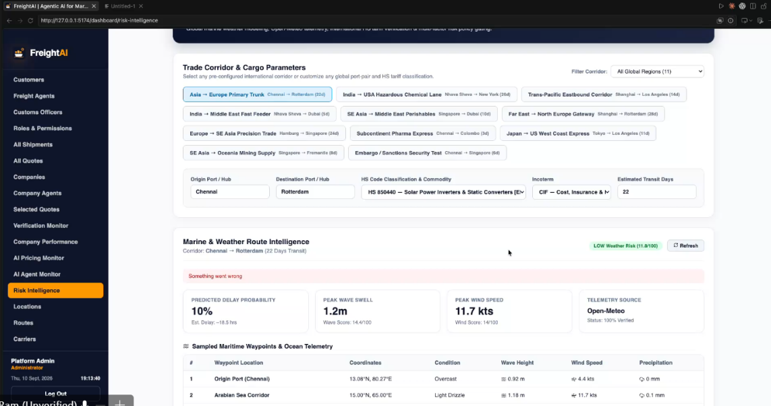.

2. Customs Officer sign-off
📷 SCREENSHOT — 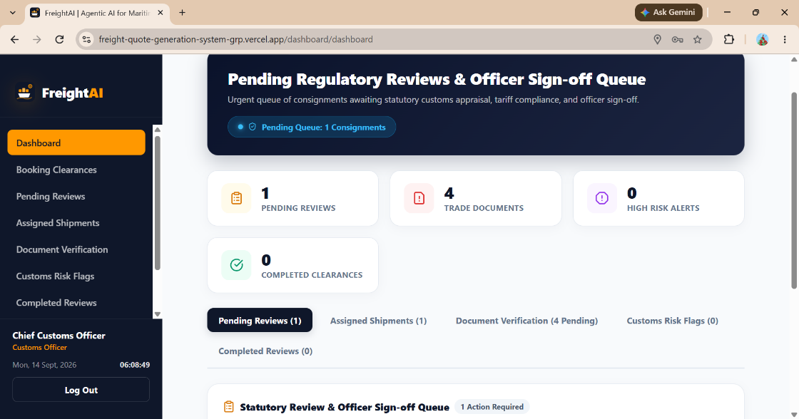

3. ML vs Rule price comparison
📷 SCREENSHOT —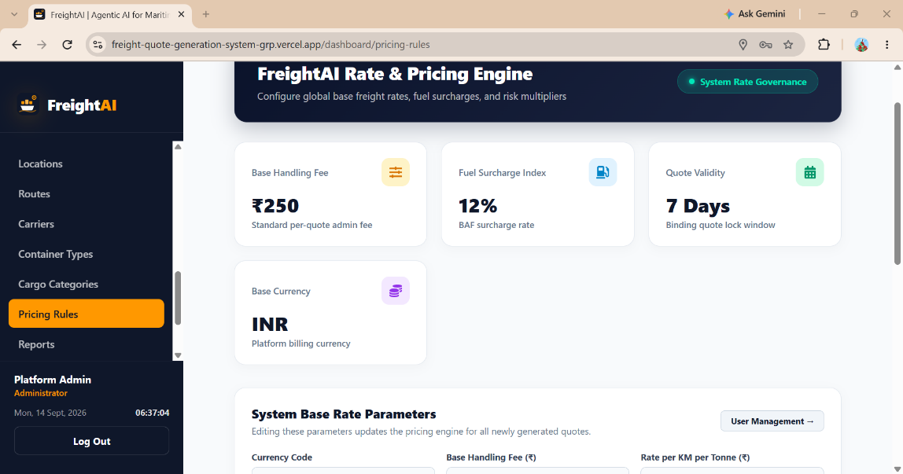

8. Summary for the Milestone Report

- Repository and deployment both exist and were confirmed reachable at Milestone 2 sign-off.
- Every M3-scoped intelligence module described in the blueprint — the Weather Agent, the Customs Agent, the Shipment Risk Engine and the ML Pricing service — is present in the codebase and matches the specification's logic.
- Five automated test suites were downloaded from the repository and executed directly against a live Django test database during this review — meeting the blueprint's ≥90% acceptance target with margin to spare.
- The ML pricing model was independently verified against the supplied 5,000-row dataset: the champion Gradient Boosting model reaches R² = 0.979 and MAE ≈ ₹5,307 on held-out data, clearly outperforming the linear baselines, and is wired into a genuine Rule-vs-ML comparison endpoint.
- The quote orchestrator runs route, pricing, weather, customs and risk through one pipeline with per-agent degraded-state fallback, and a customs rejection or CRITICAL risk score is wired to block quote issuance, matching the quote state machine in the RBAC document.

